THE OPEN UNIVERSITY OF SRI LANKA BACHELOR OF SOFTWARE ENGINEERING ACADEMIC YEAR
2021
WEB APPLICATIONS DEVELOPMENT
The Mini Project
“Website for Tourism”
EEI3346
L.I.L.H.ALWIS
S92065319

Contents

- Cover page
- Problems
- Solutions
- Site Map
- Web technologies
- Results
- Conclusion
Problems

While completing the project I had to face several problems on Finding content, building the structure and some coding difficulties.

- Finding content
  - It was challenging to find content to the website because there are so many details but I had to choose the write once, It was bit time consuming.

- Building the structure
  - The second problem was arranging the gathered details in a order to make the structure.

- coding difficulties
  - next problem was beautifying the web site using codes.

Solutions

- Found government web sites and gathered some details from there.
- Looked in to sample web sites and got an idea to make my Own.
- Referred some videos and pdf about Markup Languages.

Site Map

Home
To Do List
About Us
Contact Us
Information

Plan Your Holiday in Sri-Lanka
First Name
GEOGRAPHY

HISTROY
Last Name

Province
CULTURE

Subject
PEOPLE

PROVINCE

Web technologies
- HTML – For designing the structure of the web page.
- CSS- For Styling the Content Of the Web page.
- Vue JS – To build the TODO list.
- Java script-To Develop Navigation Bar & Search Bar.

Results
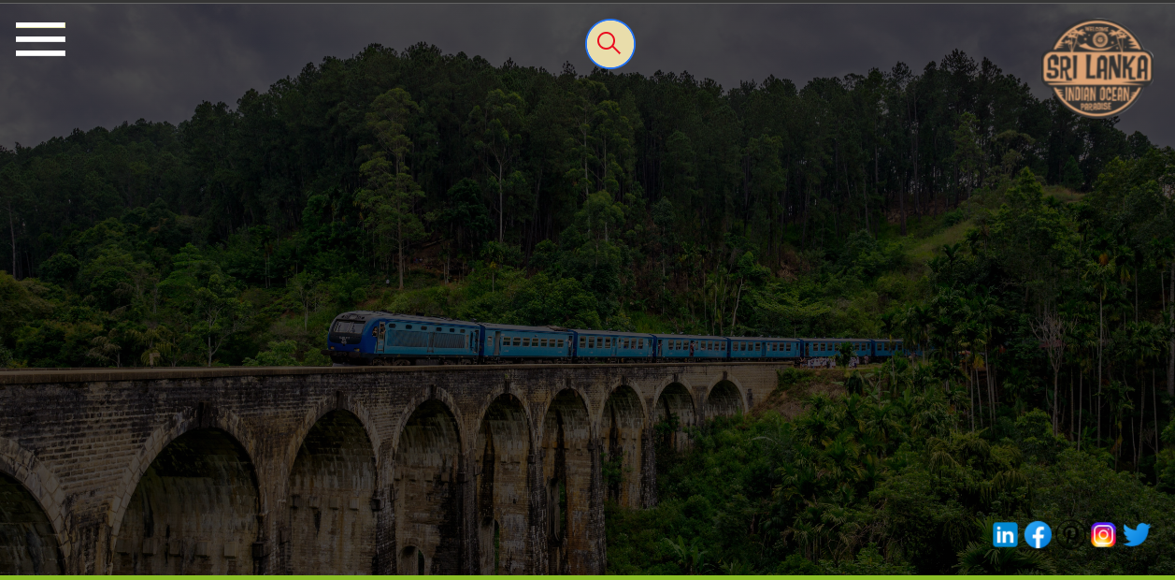
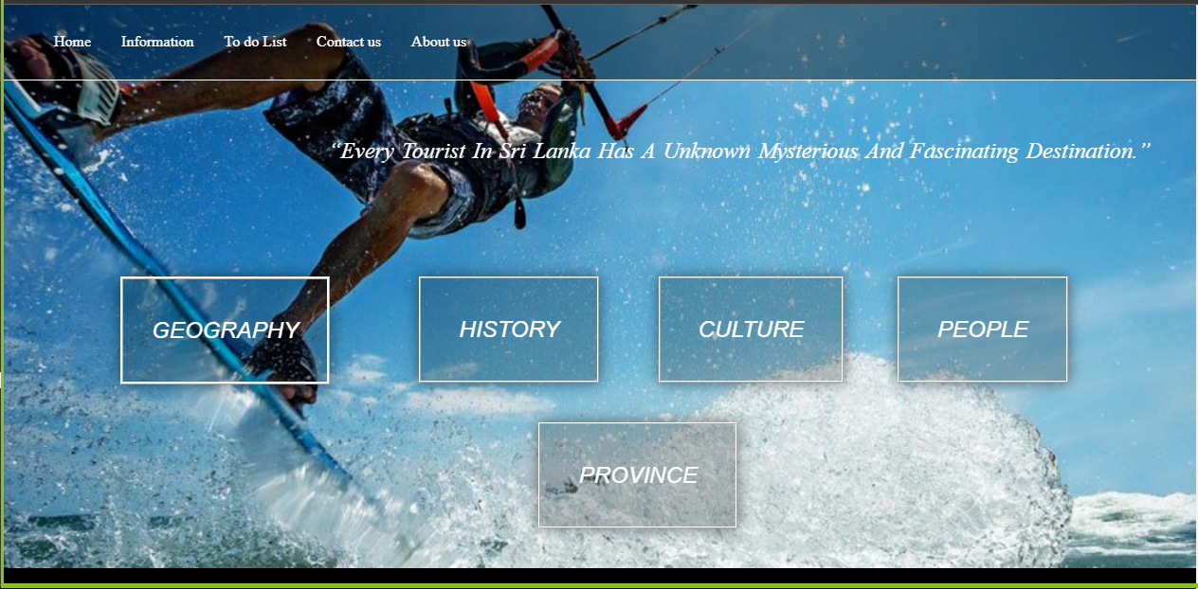
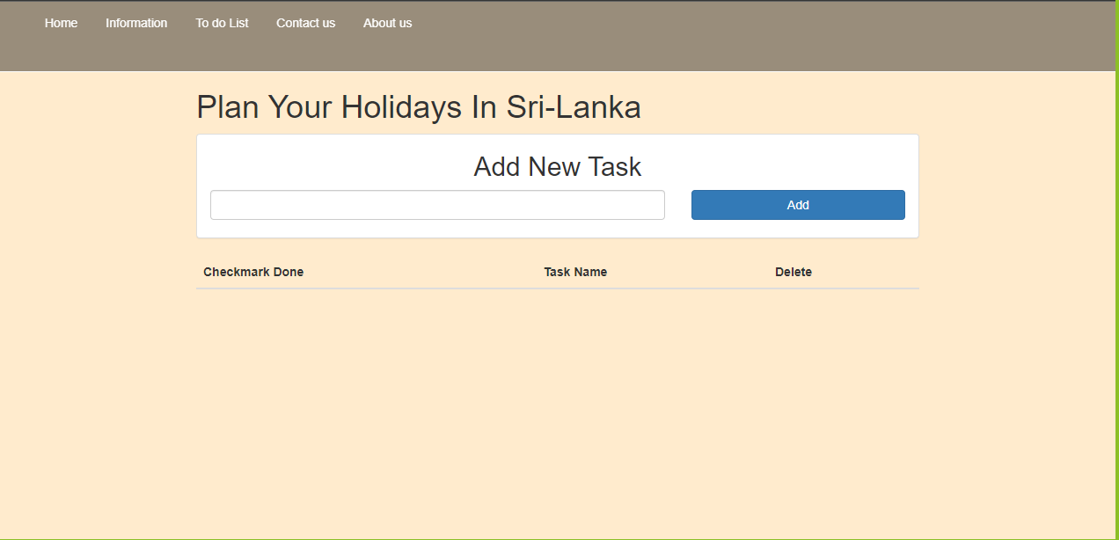
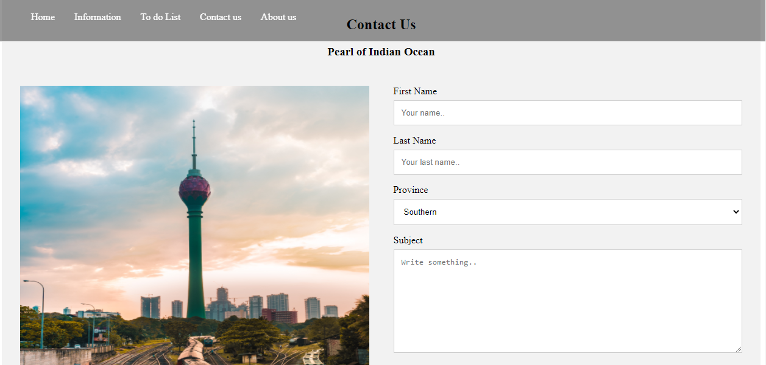

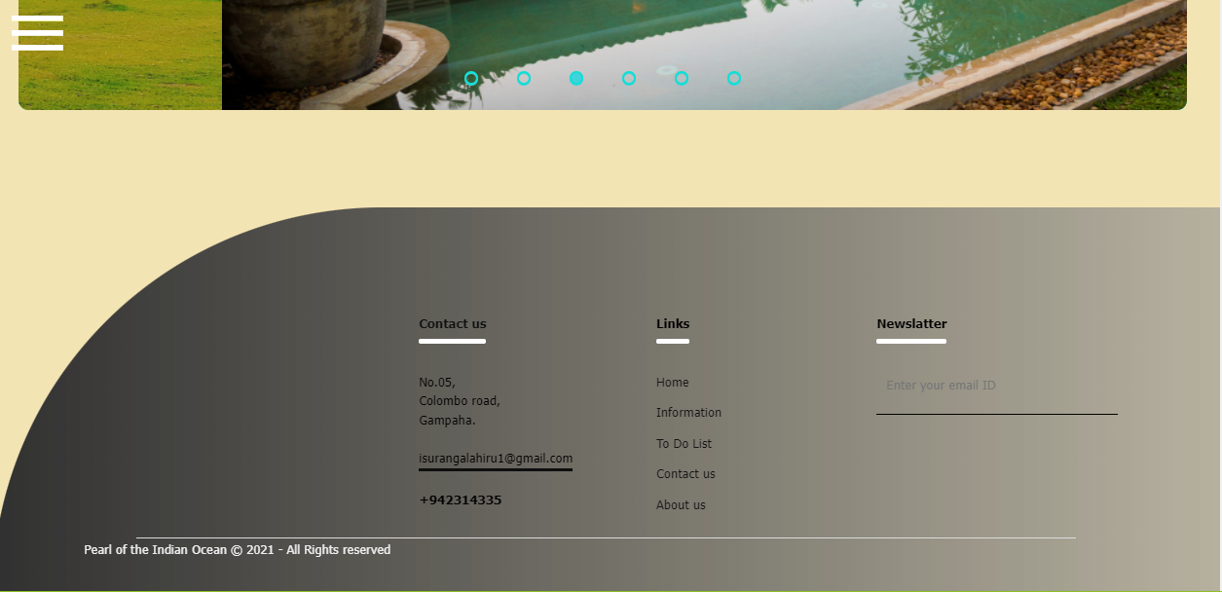

Conclusion

When developing the website the most important thing is arranging the content and the structure. After that following the plan will get the work done.

Web site link:

